Tab 1

DriveCam Minimum Lovable Product

Rowan Dey, Keenan Bromley, Xander Bailey, Sasha Hackenbruck

CS466: Software Startup I

MLP

Professor Jesse Rosenzweig

1 / 25 / 2026

Oregon State University - Cascades

Why?
The two ways a person can get a dash cam are either purchasing one, which can be expensive, especially if you want a good quality one (and you have to set it up yourself or go to a dealership, meaning more time and money spent), or installing a pre-existing app on your phone, which has questionable data practices.

Features
- Users will love having strong data security that doesn’t get in the way of using the app. This is important not only from a user perspective, but also from a business perspective, for the same reason. Currently existing dashcam apps don’t explicitly say anywhere on their app storage data-privacy page what they are actually doing with the data (or what that data even includes), other than that they share it with third parties. Due to the prevalence of data sharing in the modern digital age, there are almost certainly people who want to use a dashcam app where data sharing is not present, even with the app developers.
- Users will love being able to quickly and easily save clips, with multiple options to do so. This is important because there is no guarantee that one method of clip-saving will work in a given situation. For example, you might not even be in the proper mindset to save a clip, so the app should be able to guess when a clip needs to be saved, using something like movement. Alternatively, the user could say a specific phrase that will save a clip.
- Users will love not having to worry about data storage, running out of storage space on their phone, or losing access to potentially important clips. Video footage can take up a lot of storage space, so it’s important to give the user tools to manage and tailor it to their specific needs while also keeping that management in the background as much as possible to minimize user concerns (and to not annoy them!).

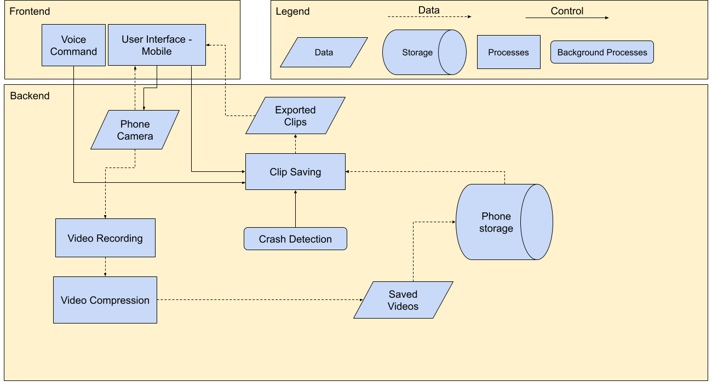
Block Diagram

Rowan’s Interviews

P1:
- Q: What do you expect a dashcam app to have?
- A: Place to access recordings, configuration (when is it on, etc), social media component (post the absurd things you see happen).
- Q: What are your must-have features?
- A: A place that saves videos, can be viewed later
- Q: Does DriveCam meet your expectations for a dashcam app?
- A: Yes
- Q: How prevalent do you want the UI to be during recording?
- A: As minimal as possible
- Additional Thoughts:
- Clip viewing icon is not clear, maybe show the most recently saved clip instead?
- Show date and time, alongside the clip length for each clip.

P2:
- Q: What do you expect a dashcam app to have?
- A: Easy way to save(!), download all clips, easy way to send clips to the insurance provider, good visibility.
- Q: What are your must-have features?
- A: Easy to save, other actions on the phone do not interrupt recording
- Q: Does DriveCam meet your expectations for a dashcam app?
- A: Yes
- Q: How prevalent do you want the UI to be during recording?
- A: Minimal, just an indication that it is recording.
- Additional Thoughts:
- If the app is minimized, still show the camera view.
- Social media component (clip of the day)

P3:
- Q: What do you expect a dashcam app to have?
- A: File storage (opt-in cloud and local), detect crashes via sensors, time-stamping, and easy-to-retrieve storage
- Q: What are your must-have features?
- A: Time-stamping
- Q: Does DriveCam meet your expectations for a dashcam app?
- A: Thinks so, wants timestamps/date
- Q: How prevalent do you want the UI to be during recording?
- A: Minimal UI, just indication of recording happening
- Additional Thoughts:
- Optional cloud integration (to your Google Drive, etc.)
- Low-storage notifications if you start recording
- Needs strong metadata on the footage to prove it is legit.

Keenan’s Interview
- Q: Do you currently have a dashcam?
- A: Yes
- Q: Roughly how much did it cost and would you say it was worth the money?
- A: $100. I would say that it is worth it because it stays there and I don’t have to think about it
- Q: How much time did you spend researching which one to get?
- A: I spent a couple hours researching but a lot of them have similar features
- Q: Would you say it was difficult to get it set up?
- A: No, I just had to stick it on my windshield, plug it in, and connect it to the app
- Q: Do you have any issues with it?
- A: Not really, sometimes it’ll randomly beep at me
- Q: What features would you expect a dashcam to have?
- A: Record, save videos, major event detection
- Q: Do you have a phone mount in your car?
- A: No, I have apple carplay so I don’t see the need to have one
- Q: What type of controls would you most enjoy using with a dashcam? (voice control, buttons, etc.)
- A: Voice control would be nice. Auto crash detection and major events would be nice too. I’d prefer not to have to touch my phone while I’m driving to get everything working.

Xander’s Interview
- Q: Do you currently have a dashcam?
- A: Yes
- Q: Roughly how much did it cost and would you say it was worth the money?
- A: Roughly $150. Yes it was worth it, we’ve been able to defend ourselves with footage from it.
- Q: How much time did you spend researching which one to get and why did you pick the one you did?
- A: Not more than 2 hours of research time. It was a brand I knew (Garmin), and I saw a review that said it was one of the better ones. The cost was reasonable and it seemed competitive with the features it had at its price point.
- Q: Would you say it was difficult to get it set up?
- A: A little more than I had thought, but it wasn’t too bad.
- Q: Do you have any issues with it?
- A: Yes. The cord can get in the way, it’s hard to get it out of the way without some kind of professional installation. It’s a lot harder to look at the videos than it should be, you have to take out the card and put it in your computer. They do have a vault service that makes it accessible from the cloud but it costs extra.
- Q: What features would you expect a dashcam to have?
- A: Voice commands, Wide angle view, Audio capture, Front and back camera (windshield and cabin camera views), No batteries to swap (plugged in instead), Enough storage to keep some amount of historical footage (either on the device or backed up to the cloud)
- Q: Do you have a phone mount in your car?
- A: Yes
- Q: What type of controls would you most enjoy using with a dashcam? (voice control, buttons, etc.)
- A: Voice is pretty great, if you’re driving you kind of have to use voice. A secondary option of a phone app would work well.

Sasha’s Interview
- Q: Do you own a car?
- A: Yes, I own a car.
- Q: How concerned are you about getting into a car wreck?
- A: Very concerned. It’s not so much that I don’t trust myself driving, I don’t trust other people.
- Q: Do you have insurance?
- A: Yes, I have insurance.
- Q: Do you already own a dash cam?
- A: No, I do not.
- Q: If you don’t own a dash cam (which you don’t), why not?
- A: It’s just not something I’ve ever gotten around to doing. Like, the research for, and…
- So too big of a barrier to entry?
- Yeah, because sometimes it also involves physical installation as well, and you have to coordinate that. It’s usually like a physical device that would have lots of wires and stuff, right?
- Q: How much time do you spend on average driving throughout a week?
- A: Maybe like 3, 4 hours. Mostly I use my car to go to and from school and go to the grocery store.
- Q: What is one feature you would want most out of a dash cam app?
- A: To automatically identify when there’s something valid, like valid to be recorded. Like, say a pedestrian walks right in front of you and you have to stop hard. You would detect that somehow and then like, save that specific part.

